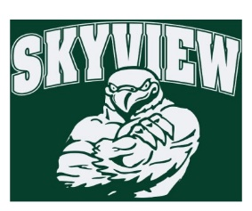
1.14.18 Edition
HAWK HAPPENINGS

Spirit Wear

For the month of January: BOGOFlannels - Buy One Get One Flannel Pants. Discount will be applied in the form of a credit at check out. This applies to both adult and youth sizing.

It has been a cold winter, stay warm with Skyview sweatshirts and flannel pjs to bundle up in!
Skyview apparel is available for purchase at yourstartinglineup.com. All items can be customized with a school logo, your name, and more. All sales benefit your child's school. All items are custom and take 2-3 weeks for delivery! www.yourstartinglineup.com.
Dine Out - This Thursday at the Valley Forge Tavern. NO flyer needed, simply mention Skyview and a portion of all sales will go to Skyview!

Looking Ahead
- January 18th – Valley Forge Tavern will host Skyview’s Dine-out
- Our 1st Spirit Night of the year is Friday, February 9th. Join your friends (an opportune time for a Parent’s Night Out!) from 7-10 pm at Skyzone for GLOWZone!
**The NEW OBSTACLE COURSE is expected to debut in time for our event! Flyers coming home soon! $4/jumper will be donated towards Skyview’s Home & School Assoc.
Glow Zone sells out quickly. Walk-ins are not advised. Advance purchase tickets on line at: http://oaksstore.skyzone.com/m/area/Info/Glow_Zone
Be sure to sign you on-line waiver and bring this flyer and your Sky Zone socks with you to check in. Sky Zone socks available for purchase $2.50.
No long lines! Sign in at the designated Skyview Fast Pass Lane when you arrive!
This fundraiser is good for any students and family members of Skyview students!!

